

**Analysis Document**

**Mark Kenny-B00074381**

**Aleena Chaudhry-B00074979**

**Heather Meagher-B00074990**

***Department of Engineering***

***School of Informatics & Engineering***

***Institute of Technology, Blanchardstown***

***Dublin 15.***

**Software Design & Quality**

**21/12/2015**

Contents

1. Introduction 1

2. Problem statement 1

3. Software Analysis 2

3.1. Use Case Analysis 2

3.1.1. High - Level Use Case model 2

3.2. Behaviour Analysis 3

3.2.1. High-level Sequence diagram 3

3.2.2. High-level State diagram 6

Table of Figures

Figure 1 High-level Use Case Analysis 2

Figure 3: User attempts Quiz 3

Figure 4: Admin Views Overall Class Report 4

Figure 5: Admin Views student (x) report 4

Figure 7 High-level Activity diagram 5

Figure 8 High-level State diagram 6

# Introduction

This document details visual models for a simple C++ Multiple Choice Quiz application. The design phase then uses abstract design models to further develop the software through multiple iterations of previously conceived models.

# Problem statement

You are required to develop a C++ Multiple Choice Quiz application to aid students taking the module “Software Design & Quality” study for their exams. Users will be presented with a randomly chosen set of 10 questions from a question bank and be presented with a choice of solutions. The user must then choose a correct answer and move to the next question. The application will generate a report of how well the student did after the quiz has been completed. The student’s result is saved to their profile. The application can manage many student profiles and can generate an overall class report. The quiz may be administrated by an admin user. An admin user has full access to all student’s attempts, but a student user can only see their own attempts as such Student’s must login to their profile before starting the quiz. Students are allowed have multiple attempts which are all persistently saved against their individual profile. Questions and solutions are saved in a simple text file which is read by the quiz application.

# Software Analysis

## Use Case Analysis

### High - Level Use Case model

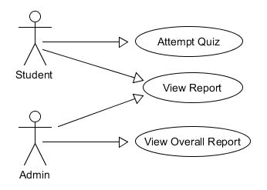

Figure 1 High-level Use Case Analysis

## Behaviour Analysis

### High-level Sequence diagram

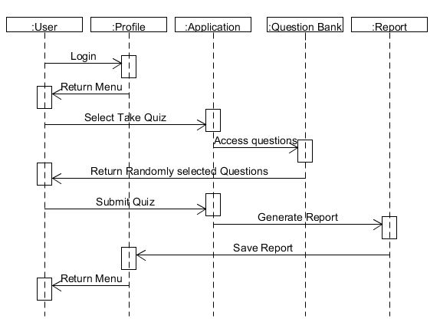

Figure 3: User attempts Quiz

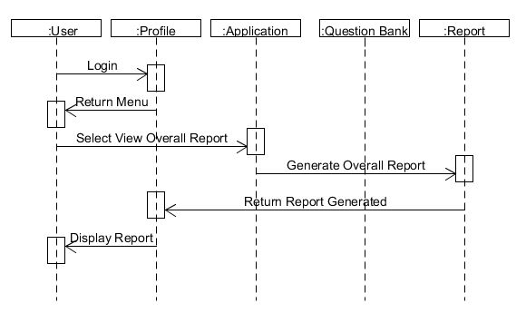

Figure 4: Admin Views Overall Class Report

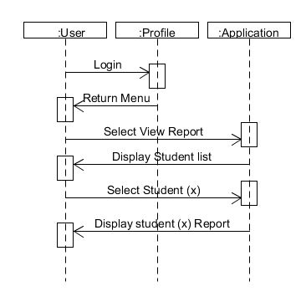

Figure 5: Admin Views student (x) report

High-level Activity diagram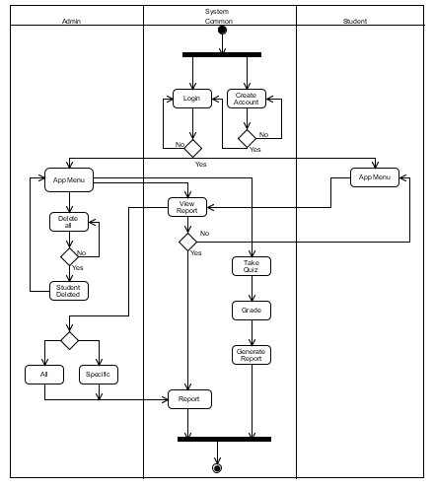

Figure 7 High-level Activity diagram

### High-level State diagram

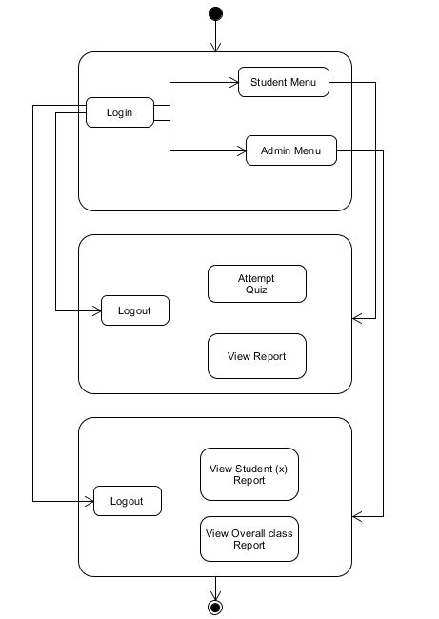

Figure 8 High-level State diagram